1. Create EmpTest from Emp table by copying structure and data.
Query:
CREATE TABLE EMPTEST AS
SELECT * FROM EMP;
Output:
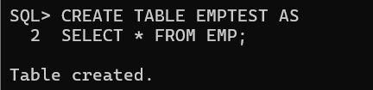
2. Add a new row into the EmpTest table for Empno, Ename, Sal columns. In Ename should have the Current User.
Query:
INSERT INTO EMPTEST (EMPNO, ENAME, SAL)
VALUES (9999, USER, 4000);
SELECT EMPNO, ENAME, SAL
FROM EMPTEST
WHERE EMPNO = 9999;
Output:
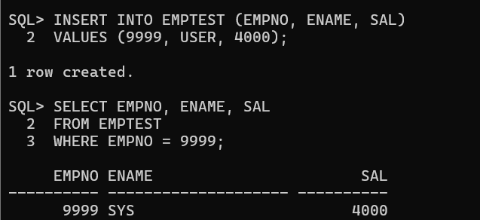

3. Update EmpTest by increasing the Salary of TURNER by 15%. Confirm your changes.
Query:
UPDATE EMPTEST
SET SAL = SAL * 1.15
WHERE ENAME = 'TURNER';
SELECT EMPNO, ENAME, SAL
FROM EMPTEST
WHERE ENAME = 'TURNER';
Output:
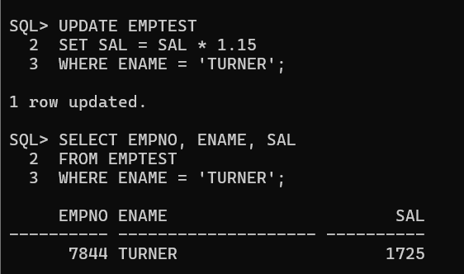

4. Update the salary of Smith with salary of Scott using EmpTest table.
Query:
UPDATE EMPTEST
SET SAL = (SELECT SAL
FROM EMPTEST
WHERE ENAME = 'SCOTT')
WHERE ENAME = 'SMITH';
SELECT EMPNO, ENAME, SAL
FROM EMPTEST
WHERE ENAME IN ('SMITH', 'SCOTT');
Output:
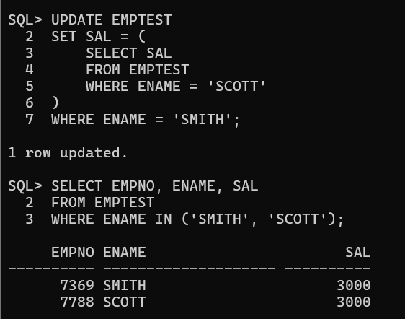

5. Increase all the employees salary by 10% in EmpTest table who are working in NEW YORK.
Query:
UPDATE EMPTEST SET SAL = SAL * 1.10
WHERE DEPTNO IN (SELECT DEPTNO
FROM DEPT
WHERE LOC = 'NEW YORK');
SELECT EMPNO, ENAME, SAL, DEPTNO FROM EMPTEST
WHERE DEPTNO = (SELECT DEPTNO
FROM DEPT
WHERE LOC = 'NEW YORK');
Output:
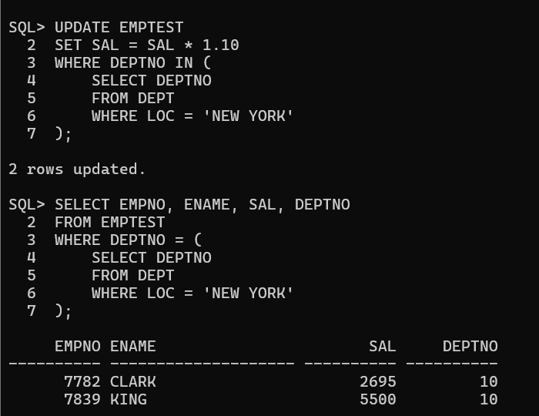

6. Delete all the Comm data from EmpTest Table.
Query:
DELETE FROM EMPTEST
WHERE COMM IS NOT NULL;
SELECT EMPNO, ENAME, COMM
FROM EMPTEST;
Output:
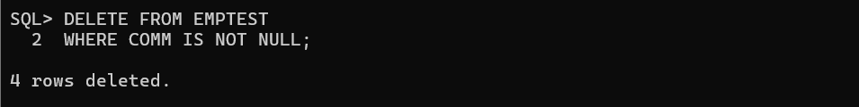
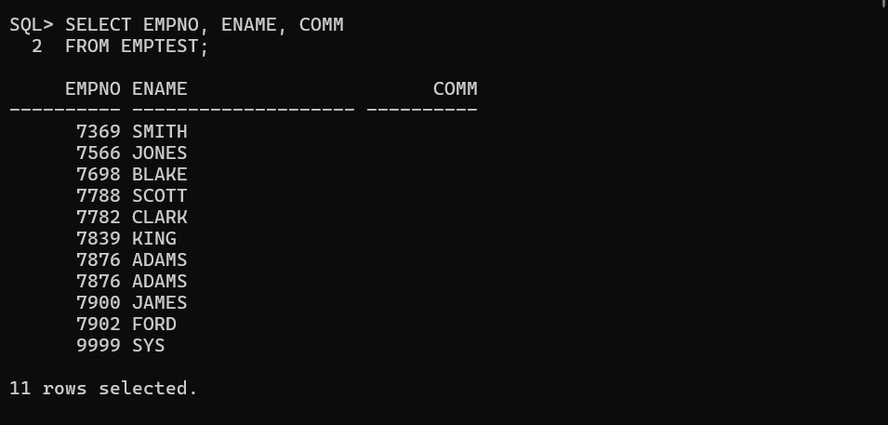

7. Delete all the employees from EmpTest table who are working in SALES dept.
Query:
DELETE FROM EMPTEST
WHERE DEPTNO = (SELECT DEPTNO
FROM DEPT
WHERE DNAME = 'SALES');
SELECT * FROM EMPTEST
WHERE DEPTNO = 30;
Output:
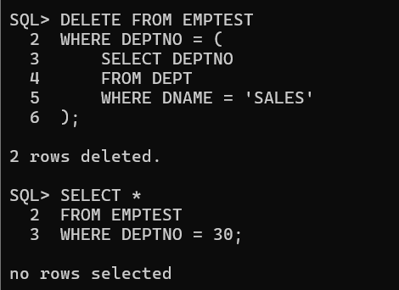

8. Delete all the who are working with that employee, except that Employee. (Prompt for the ENAME).
Query:
DELETE FROM EMPTEST
WHERE DEPTNO = ( SELECT DEPTNO
FROM EMPTEST
WHERE ENAME = UPPER('&ENAME'))
AND ENAME <> UPPER('&ENAME');
SELECT * FROM EMPTEST
WHERE DEPTNO = (SELECT DEPTNO
FROM EMPTEST
WHERE ENAME = 'SMITH');
Output:
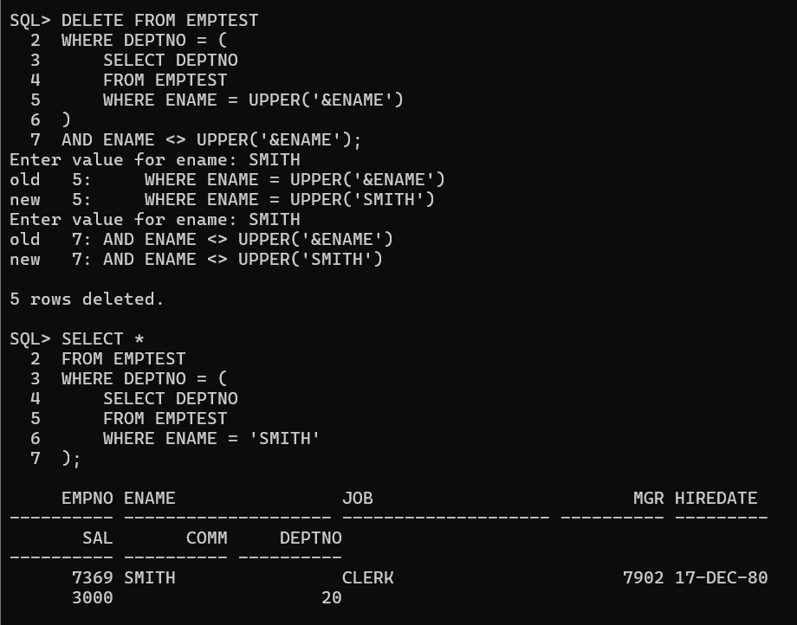

9. Create Emp2 from Emp by only copying Empno, Ename, sal without copying data.
Query:
CREATE TABLE EMP2 AS
SELECT EMPNO, ENAME, SAL
FROM EMP
WHERE 1 = 2;
SELECT * FROM EMP2;
Output:
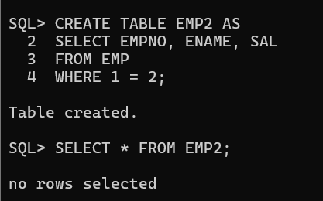
10. Create Emp3 from Emp by only copying Empno, Job without copying data.
CREATE TABLE EMP3 AS
SELECT EMPNO, JOB
FROM EMP
WHERE 1 = 2;
SELECT * FROM EMP3;
Output:
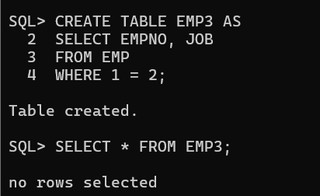

11. Using multitable insert Emp data into Emp2 and Emp3 Tables.
Query:
INSERT ALL INTO EMP2 (EMPNO, ENAME, SAL)
VALUES (EMPNO, ENAME, SAL)
INTO EMP3 (EMPNO, JOB)
VALUES (EMPNO, JOB)
SELECT EMPNO, ENAME, SAL, JOB
FROM EMP;
SELECT * FROM EMP2 ORDER BY EMPNO;
SELECT * FROM EMP3 ORDER BY EMPNO;
Output:
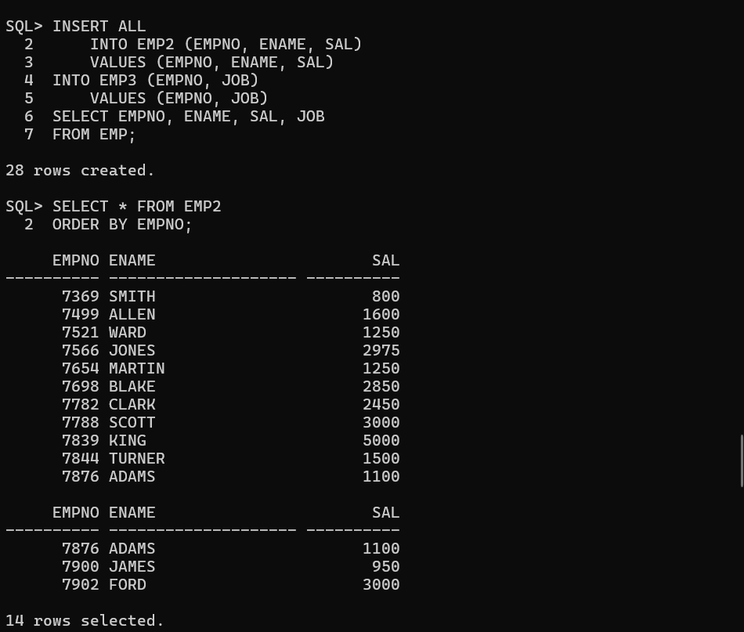
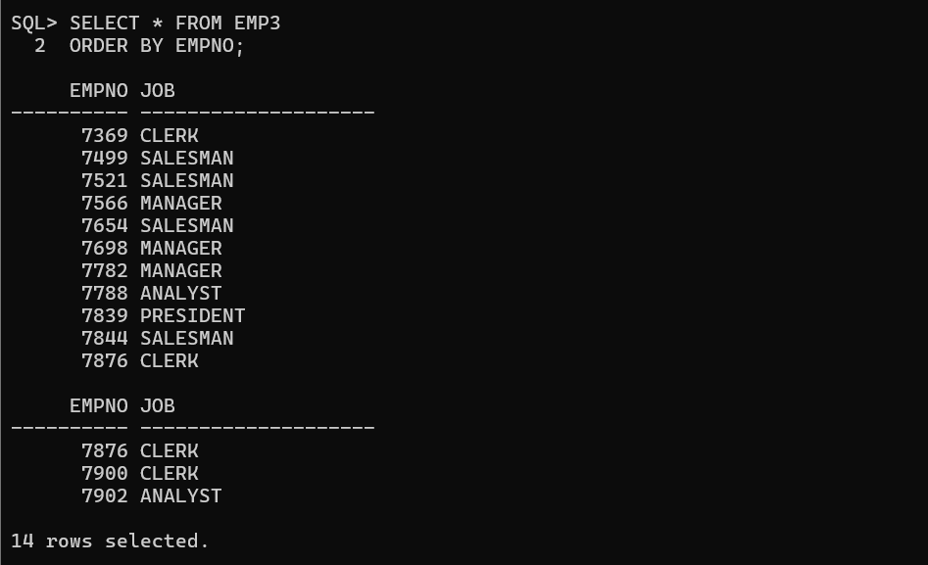

12. Truncate Emp2 Table and insert following two rows as follows: 7788, SMITH, 4500 / 7654, JACK, 3500
Query:
TRUNCATE TABLE EMP2;
INSERT INTO EMP2 (EMPNO, ENAME, SAL)
VALUES (7788, 'SMITH', 4500);
INSERT INTO EMP2 (EMPNO, ENAME, SAL)
VALUES (7654, 'JACK', 3500);
SELECT * FROM EMP2
ORDER BY EMPNO;
Output:
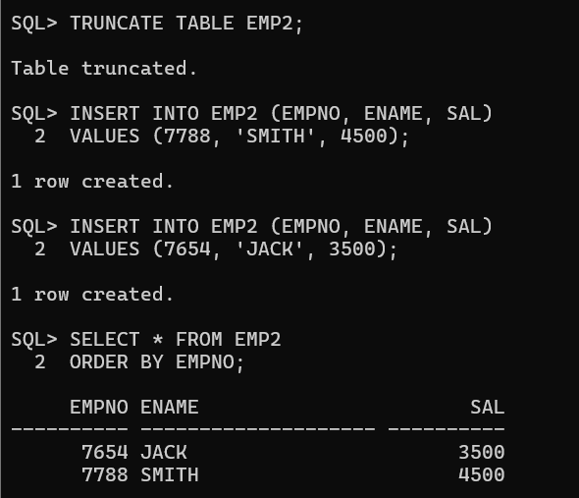
13. Commit the Data.
Query:
COMMIT;
Output:
14. Using Merge statement insert and update Emp2 using Emp.
Query:
MERGE INTO EMP2 T
USING EMP S
ON (T.EMPNO = S.EMPNO)
WHEN MATCHED THEN
UPDATE SET
T.ENAME = S.ENAME,
T.SAL = S.SAL
WHEN NOT MATCHED THEN
INSERT (EMPNO, ENAME, SAL)
VALUES (S.EMPNO, S.ENAME, S.SAL);
Output:
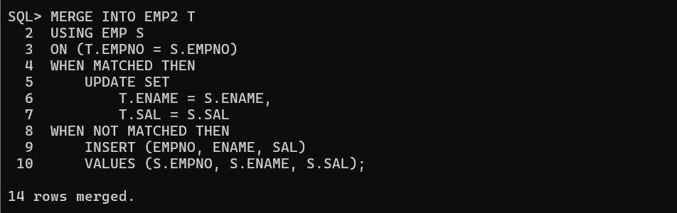

15. Verify your changes.
Query:
SELECT *
FROM EMP2
ORDER BY EMPNO;
Output:
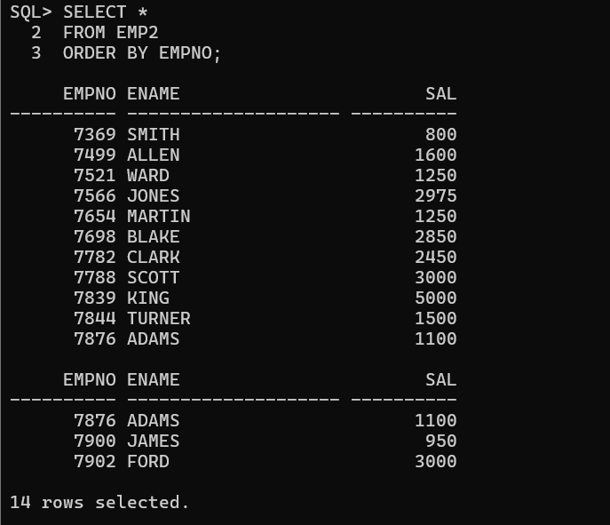

16. Rollback the Data.
Query:
ROLLBACK;
SELECT * FROM EMP2
ORDER BY EMPNO;
Output:
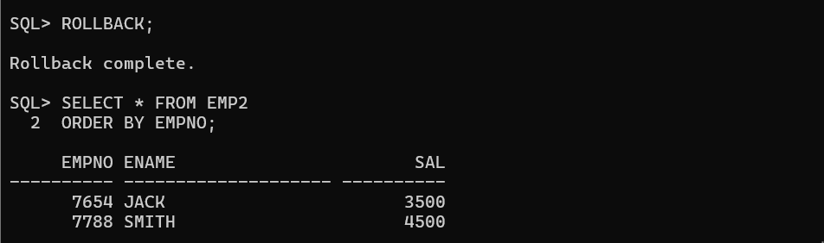
17. Using Merge statements update Emp2 table for only Empno=7788 and Insert only those employees whose salary is more than 3000.
Query:
MERGE INTO EMP2 T
USING EMP S
ON (T.EMPNO = S.EMPNO)
WHEN MATCHED THEN
UPDATE SET
T.ENAME = S.ENAME,
T.SAL = S.SAL
WHERE S.EMPNO = 7788
WHEN NOT MATCHED THEN
INSERT (EMPNO, ENAME, SAL)
VALUES (S.EMPNO, S.ENAME, S.SAL)
WHERE S.SAL > 3000;

Output:
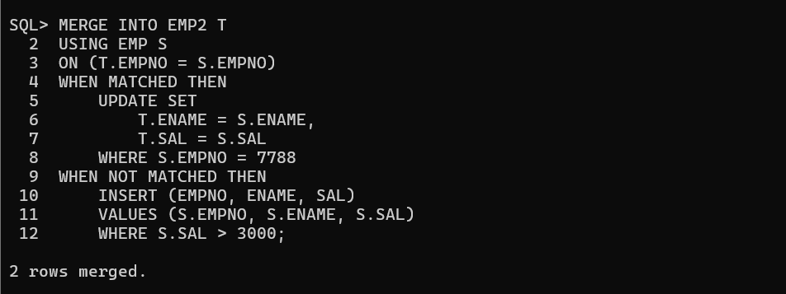
18. Verify your changes.
Query:
SELECT *
FROM EMP2
ORDER BY EMPNO;
Output:
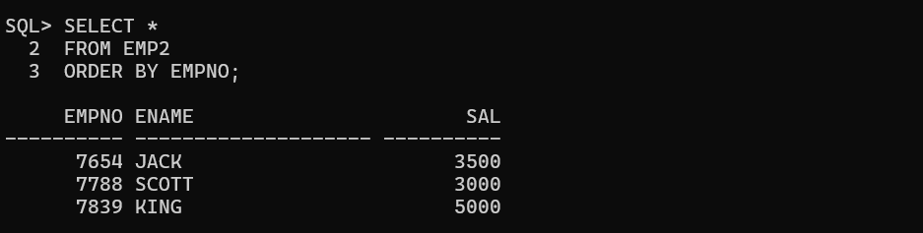
19. Create a User WIPRO.
Query:
CREATE USER WIPRO IDENTIFIED BY password123;
GRANT CREATE SESSION TO WIPRO;
Output:
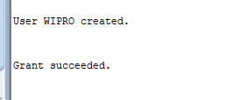

20. Grant ALL permission on EMP table from SCOTT to WIPRO user.
Query:
GRANT ALL ON Emp TO WIPRO;
Output:

21. Delete all the employees in deptno 10 and do not issue a Commit.
Query:
DELETE FROM Emp WHERE Deptno = 10;
Output:
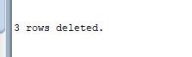
22. From WIPRO user delete all the employees from SCOTT.EMP table in DEPTNO=10. What happens and Why?
Query:
DELETE FROM SCOTT.Emp WHERE Deptno = 10;
Output:
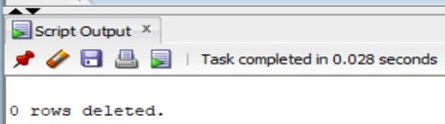

23. Issue a Rollback in SCOTT user and Check the WIPRO user.
Query:
ROLLBACK;
SELECT * FROM SCOTT.Emp WHERE Deptno = 10;
Output:

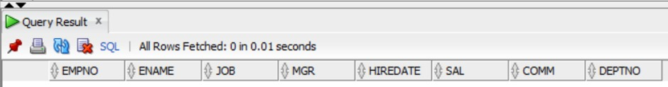
24. In SCOTT user give a query on EMP using FOR UPDATE clause with WAIT 20 seconds. What happens?
Query:
SELECT * FROM Emp WHERE Deptno = 10 FOR UPDATE WAIT 20;
Output:

25. In WIPRO User issue a ROLLBACK and now check in SCOTT user.
Query:
ROLLBACK;
Output:


26.ROLLBACK all the transactions in SCOTT and WIPRO Users.
Query:
ROLLBACK;
Output:


